Elk Valley

Accessibility Plan
2025 - 2028

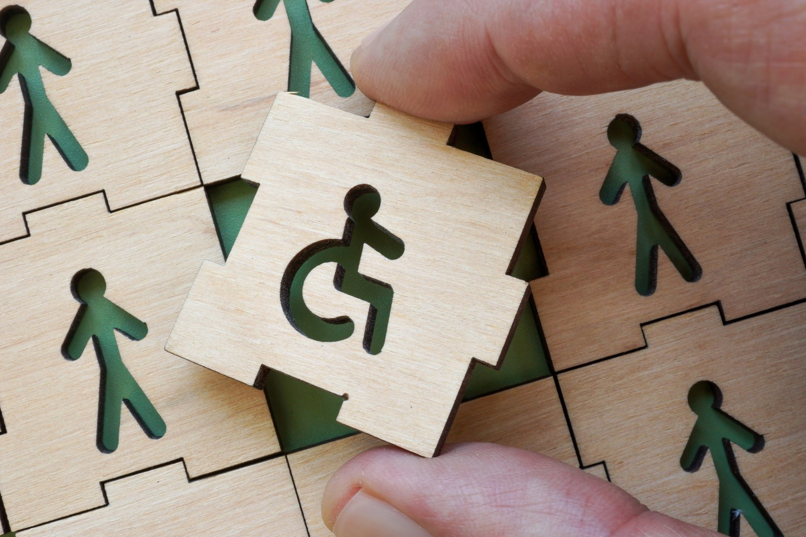

March 2025

Prepared by:
Bolt Access & Design Co.
Box 387, Invermere, BC V0A 1K0 T: 778-678-5568
Contact:
Tanelle Bolt, DID, Access & Design Consultant
tanellebolt@gmail.com
Prepared for:

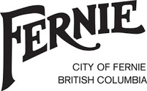


Territorial Acknowledgement
We acknowledge that the Elk Valley is located within Qukinʔamakʔis, the unceded traditional territory of Ya
´qit ʔa·knuqⱡi’it. We recognize that we play, live and work within their vast lands. ʔakanuxunik are from Ya´qit ʔa·knuqⱡi’it and are members of the Ktunaxa speaking peoples of British Columbia, Idaho and Montana.

EXECUTIVE SUMMARY

The Elk Valley Accessibility Plan unites the District of Elkford, District of Sparwood, and the City of Fernie in a shared commitment to creating barrier-free communities where all individuals can participate fully and equally. This collaborative plan, developed in alignment with Part 3 of the Accessible British Columbia Act and other relevant legislation, outlines strategies to address physical, social, and systemic barriers that impact the daily lives of residents and visitors with disabilities.
The plan’s priorities were informed by community feedback, site assessments, and legislative requirements. Key areas of focus include:
Physical Accessibility: Improving ramps, elevators, automatic door openers, washrooms, sidewalks, and accessible parking at municipal buildings and public spaces.
Transportation and Mobility: Addressing limited public transit, poor sidewalk maintenance, snow removal, and insufficient accessible parking to ensure safe and independent travel for all.
Communication and Information: Ensuring municipal communication is inclusive and accessible, using plain language and multiple platforms to meet diverse needs.
Employment and Training: Promoting inclusive hiring practices and providing accessibility and disability awareness education for municipal staff.
Emergency Preparedness: Developing clear, accessible, and inclusive emergency plans that consider the diverse needs of all residents

With input gathered from the public through surveys, public events, and committee feedback the key findings revealed significant barriers, including inaccessible public spaces, limited transportation options, inadequate communication, and challenges in employment and community participation. The Elk Valley Regional Accessibility Committee is composed of local advocates and experts who played a critical role in identifying priorities and shaping actionable strategies.
This plan emphasizes collaboration, continuous improvement, and accountability. Progress will be monitored through regular audits, public feedback, and biennial reports, ensuring the plan remains responsive to evolving community needs. By prioritizing accessibility, Elkford, Sparwood and Fernie are working together to build inclusive and resilient mountain communities where everyone can thrive.
This plan is not just a compliance measure but a living document and long-term commitment to fostering equity, independence, and dignity for all. Through a shared vision, the Elk Valley is paving the way for a more accessible future for generations to come.

Table of Contents

Introduction 08
Our Accessibility Story 10
Engaging Our Communities 11
Our Accessibility Committee 12
Message From Municipalities 15
Message From the Mayors 16
Message From The Committee 17
Acknowledgements 18
Definitions 19
The Framework 20
Guiding Principles 23
Key Legislation 24
Consultations Conducted 25
How To Give Us Feedback 28
Community Feedback 29
Accessibility Committee Feedback 30
Priorities 32
Action Plan 34
Monitoring Progress 40 6
Table of Contents
How To Give Us Feedback 42
Provincial Feedback Mechanism 43
Our Commitment 44
Appendix 1 45
Appendix 2 49
Appendix 3 55
Appendix 4 56
Appendix 5 59
Appendix 6 61
Appendix 7 62

Introduction

The Elk Valley Region
Elkford, Sparwood, and Fernie are vibrant communities located in the picturesque Elk Valley of southeastern British Columbia. Nestled within the rugged Rocky Mountains, these municipalities are part of the East Kootenay region and are surrounded by breathtaking natural landscapes, rich history, and strong community spirit. The region is connected by shared economic, cultural, and recreational opportunities, and is recognized for their efforts to balance industrial development with environmental preservation and community well- being.

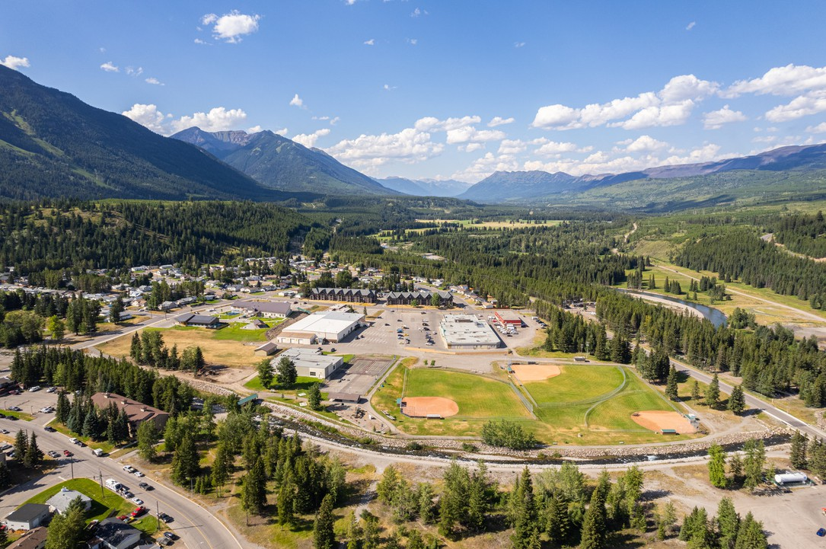
ELKFORD, a small but dynamic town with a population of approximately 2,749 residents. This remote mountain community was originally established as a home for workers in the mining industry and remains closely tied to its¹ resource-based economy.
Elkford’s proximity to pristine wilderness areas makes it a haven for outdoor enthusiasts, offering activities such as hiking, fishing, and wildlife observation.

- https://www12.statcan.gc.ca/census-recensement/2021/as-sa/fogs-spg/Page.cfm?lang=e&topic=1&dguid=2021A00055901003

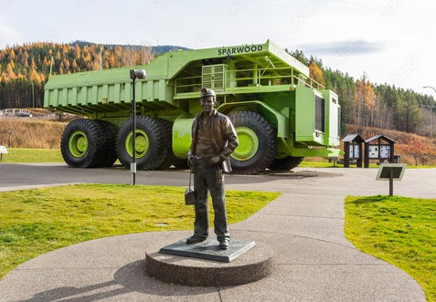
SPARWOOD, a town of approximately 4,148 residents.² It is a community that celebrates its mining heritage while embracing opportunities for growth and innovation. Sparwood is known for being home to the ‘world’s largest truck’, the Terex Titan, an attraction that draws visitors from around the globe.

FERNIE, the largest municipality in the Elk Valley, boasts a population of approximately 6,320 residents³and is renowned for its historic charm and world-class recreational opportunities. The town’s vibrant downtown core features well-preserved heritage buildings, boutique shops, and a thriving arts and culture scene. Fernie is also a major hub for outdoor activities, including skiing at the Fernie Alpine Resort, mountain biking, and fishing along the Elk River.
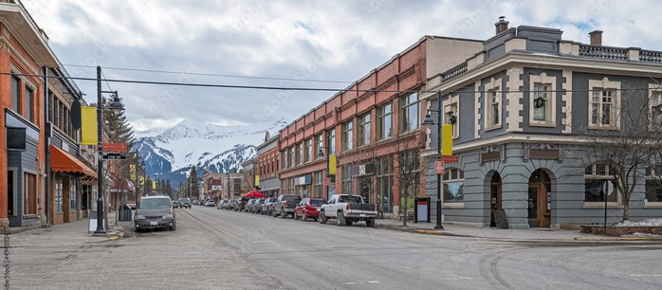

- https://www12.statcan.gc.ca/census-recensement/2021/as-sa/fogs-spg/page.cfm?topic=1&lang=e&dguid=2021A00055901006
- https://www12.statcan.gc.ca/census-recensement/2021/as-sa/fogs-spg/page.cfm?topic=1&lang=e&dguid=2021A00055901012

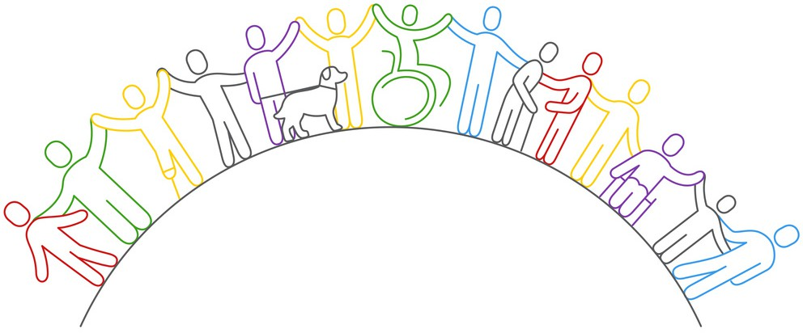
Our Accessibility Story

In acknowledging the collective strength of Elkford, Sparwood, and Fernie, our commitment to creating accessible communities goes beyond meeting legal requirements. These Elk Valley towns share a rich history of resilience and collaboration, shaped by their unique mountain landscapes and tight-knit communities. However, historically, accessibility has not been a primary focus, leaving individuals with disabilities and mobility challenges facing barriers to fully participating in community life.
Before the introduction of accessibility legislation, there was limited awareness and prioritization of accessibility concerns in these municipalities. This has impacted residents and visitors with physical, sensory, and informational accessibility needs, preventing them from accessing public spaces, services, and opportunities that others take for granted.
Recognizing these challenges, Elkford, Sparwood, and Fernie are now working together to address barriers and create inclusive environments for everyone. This Accessibility Plan is not just a compliance measure but a shared regional commitment to foster communities where all individuals, regardless of ability and age, can thrive and fully participate. By working collaboratively, the Elk Valley is taking meaningful steps toward building a stronger, more resilient, inclusive and accessible future for everyone.

Engaging Our Communities
The active involvement of community members in the Elk Valley will be the key to our success. Their insights, experiences, and perspectives are invaluable as we shape our accessibility plan. Together, we can ensure that our initiatives reflect the diverse needs of our villages, fostering an environment where everyone feels heard and represented.
As the paradigm of accessibility is shifted from an annual mandate to a progressively innovative and inclusive mindset, the journey toward accessibility is ongoing, and we are excited about the positive impact we can collectively make. Through continuous collaboration, open communication, evaluation and a dedication to inclusion, we aim to build communities that stand as beacons of accessibility for the benefit and inclusion of all.


Thank you for being part of this important endeavor. Together, we are creating a future where accessibility is not just a goal, but a lived reality.

Our Accessibility Committee

The Elkford, Sparwood, and Fernie Regional Accessibility Committee serves as a vital body dedicated to advancing inclusion and accessibility across the three communities. This committee supports the District of Elkford, District of Sparwood, and the City of Fernie in identifying and addressing physical and social barriers that impede full participation in community life. The committee also provides a forum for discussing accessibility challenges and raising awareness about accessibility issues within the region.
Appointment Process
The Chief Administrative Officers (CAOs) of Elkford, Sparwood, and Fernie appoint the committee members, ensuring representation from each community. The committee consists of up to six voting members, including one member from each of the three communities and additional individuals who are either persons with disabilities or supporters of accessibility initiatives. To the extent possible, the committee reflects the diversity of persons with disabilities in British Columbia, including Indigenous representation. Members are appointed for a two-year term, which can be extended upon agreement by the CAOs.
The committee rotates meeting responsibilities among the three communities, with the host community providing support for agenda preparation and logistics. Committee members serve without remuneration, and attendance is required to maintain an active appointment.

Importance of Internal Staff
Each community’s CAO appoints a staff liaison to provide non-voting support and ensure that the committee's recommendations align with municipal priorities and resources. Staff liaisons contribute operational insights, which enrich discussions and ensure practical, community- specific recommendations.

Scope and Purpose
The committee’s mandate, outlined in the Terms of Reference document, includes assisting Elkford, Sparwood, and Fernie in developing and maintaining their accessibility plans. It is responsible for providing advice on removing barriers, improving accessibility in municipal services, and identifying best practices. The committee also engages with the public to solicit feedback, ensuring that its work is informed by the lived experiences of residents and visitors with accessibility challenges.
The scope of work includes:
Reviewing and researching accessibility best practices.
Advising on specific projects or matters referred by councils or staff. Assessing current accessibility conditions in the three communities.
Liaising with government and non-government organizations on related issues.
Developing processes for receiving and responding to public comments regarding accessibility concerns.

Summary
The Elkford, Sparwood, and Fernie Regional Accessibility Committee represents a collaborative approach to enhancing accessibility and inclusion in the region. By bringing together community members, staff, and external perspectives, the committee ensures that its work is informed, inclusive, and aligned with the needs of the people in the Elk Valley. This unwavering commitment to accessibility will actively cultivate a more inclusive and equitable community for everyone.


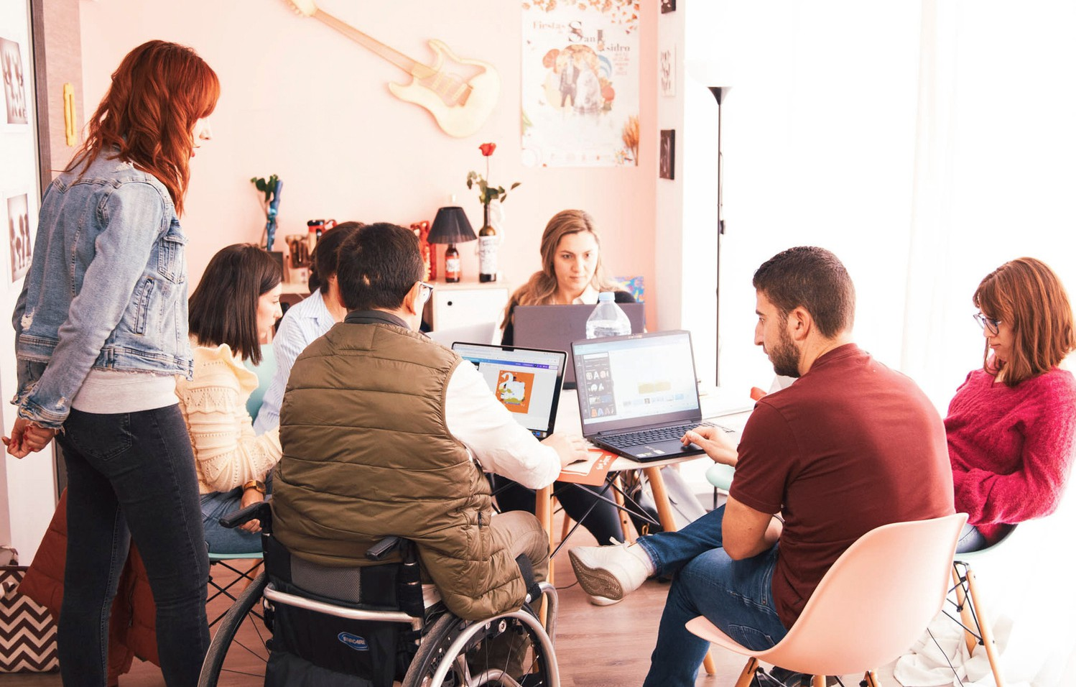

Message from Municipalities

The municipalities of Elkford, Sparwood and Fernie are proud to have partnered on the development of the Elk Valley Regional Accessibility Plan. This Plan represents a significant step forward in our collective commitment to creating a more inclusive and accessible region for residents and visitors alike.
In alignment with the Accessible British Columbia Act, this Plan is the result of extensive collaboration, thoughtful consideration, and valuable input from residents who face disabilities within our communities. We recognize that accessibility is not just a legal obligation, but a fundamental human right.
This Regional Accessibility Plan outlines our strategies and actions to identify, remove and prevent barriers to accessibility. The priority focus areas are:
Knowledge: Staff training to build knowledge and understanding of accessibility.
Public spaces and facilities: Removing barriers in municipal spaces and facilities.
Communication: Improve communication to ensure it is clear, transparent and shared across multiple platforms.
This plan is a living document, and we are committed to its ongoing implementation and review.

We will continue to engage with our communities to ensure that our region remains forward thinking and proactive in improving accessibility.

Messages from the Mayors

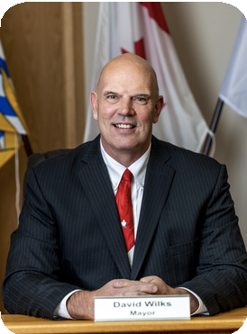
On behalf of the District of Sparwood, we sincerely thank those who contributed to the development of the Elk Valley Regional Accessibility Plan. This document will serve to guide the District now and in the years to come as we continue to improve access to our spaces and services, ensuring everyone feels welcome, safe and able to participate in all that our community has to offer.

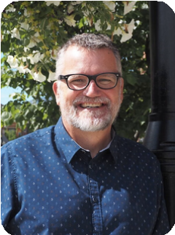
David Wilks

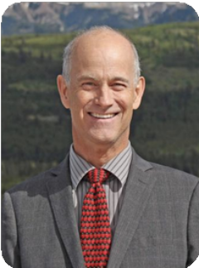
Nic Milligan

Steve Fairbairn

Fernie prides itself on being an inclusive and accessible community. With the development Elk Valley Regional Accessibility Plan, we now have an indispensable tool to support our efforts to ensure we continue to grow as a community that meets the needs of every citizen and visitor. Born of collaboration, the Plan provides a roadmap for greater inclusivity and participation within our own facilities and for all our natural amenities.

Accessibility is not just about physical infrastructure—it’s also about attitudes, understanding and creating a culture of inclusion. In Elkford, we recognize that the path to true accessibility is a journey that we have embarked on together. This Accessibility Plan reflects this commitment. It represents not just what we’ve already done, but what we will continue to do as a community and a region to ensure that everyone feels welcomed, valued and able to participate fully in the life of our town. I want to extend my heartfelt thanks to everyone who contributed to the development of this plan—your input, passion and dedication are helping shape a more accessible Elk Valley for all.

Message from the Committee
As members of the Elk Valley Accessibility Advisory Committee, we are honored to share the Elk Valley Accessibility Plan for 2025–2028. This plan represents a united vision among the District of Elkford, District of Sparwood, and City of Fernie to create inclusive, barrier-free communities where all individuals can participate fully and with dignity.
Our committee is composed of individuals from diverse backgrounds, lived experiences, and areas of expertise, including those with disabilities and those who advocate for improved accessibility. This diversity has been instrumental in shaping a thoughtful and comprehensive plan that reflects the unique needs of our communities.
Through collaboration with residents, advocates, and municipal leaders, this plan identifies barriers and outlines actionable steps to address them. It is a reflection of our collective commitment to fostering equality, independence, and inclusion for all members of our community.
We are excited to see the initiatives in this plan come to life and to continue working together to ensure the Elk Valley becomes a model for accessibility. Thank you to everyone who has contributed to this important work—we look forward to ongoing collaboration as we build a more inclusive future.

Sincerely,
The Elk Valley Regional Accessibility Committee

Acknowledgments


THANK YOU to the municipal councils and staff of Elkford, Sparwood, and Fernie for their dedication and collaborative efforts in crafting this Accessibility Plan.
Special thanks go to the Accessibility Advisory Committee, whose members have guided this process with their invaluable expertise, lived experiences, and active community involvement. Their work has been instrumental in identifying barriers and shaping actionable strategies to address the unique challenges faced by residents and visitors alike.
We also acknowledge the contributions of the many individuals and organizations who participated in our public outreach efforts. Your feedback, insights, and personal stories have been critical in ensuring this plan reflects the voices and needs of our diverse community.
Appendix 2. Without this team of advocates, the achievement of our accessibility goals would not be possible.
Thank you for your dedication to this important work. Together, we are building a future where accessibility is not just an aspiration but a lived reality.

Definitions
PWD - persons with disabilities
As defined in the Accessible British Columbia Act:
“Barrier” is anything that hinders the full participation in society of a person with an impairment. Barriers can be caused by the environment, attitudes, practices, policies, information, communications or technologies and can be affected by intersecting forms of discrimination.
“Disability” means an inability to participate fully and equally in society as a result of the interaction of an impairment or barrier.
“Impairment” includes a physical, sensory, mental, intellectual or cognitive difference from what society has termed ‘normal’, whether permanent, temporary, or episodic.

See more definitions in Appendix 3 - Research.

The Framework

Our Foundation: The Accessible BC Act (2021)
The framework shaping our accessibility initiatives is grounded in the Accessible British Columbia Act (2021), Part 3, which outlines eight key standards for building accessible communities:

EMPLOYMENT
Promoting inclusive hiring practices and supporting meaningful employment opportunities for people with disabilities.

DELIVERY OF SERVICES
Creating programs and services that are accessible in many different ways and designed to support diverse needs.

THE BUILT ENVIRONMENT
Ensuring physical spaces, such as municipal buildings, parks, parking and sidewalks, are accessible to everyone.

INFORMATION AND COMMUNICATION TECHNOLOGIES
Providing clear, accessible, and inclusive digital and technological resources.

TRANSPORTATION
Enhancing connectivity and mobility through accessible, interconnected, considerately designed transportation systems and infrastructure.

HEALTH
Ensure equitable access to healthcare services and facilities for people with disabilities, removing barriers to care.

EDUCATION
Supporting inclusive and accessible education practices for all ages.

PROCUREMENT OF GOODS, SERVICES, AND FACILITIES
Embedding accessibility into purchasing decisions to ensure equitable distribution of public resources.

Committing to Compliance
Under the Act, Elkford, Sparwood, and Fernie are committed to fulfilling the following requirements:
- Establishing an Accessibility Advisory Committee to provide expertise and guide decision-making.
- Developing a comprehensive and actionable Accessibility Plan to identify and address barriers.
- Creating a diverse public-facing Feedback Mechanism to ensure ongoing input from people living in and visiting the community on accessibility needs and improvements.

A Shared Responsibility
Our work is rooted in collaboration, guided by the belief that accessibility benefits everyone in our region—residents and visitors alike. By focusing on proactive solutions and fostering a culture of inclusion, we aim to build a future where accessibility is woven into daily life, supporting a vibrant and equitable community for all, and empowering individuals to live with dignity and independence in the stunning Rocky Mountains.

Integration with Broader Community Goals
Our framework will work seamlessly with other municipal plans and strategies. By integrating accessibility into broader community goals— such as economic development, environmental sustainability, and social inclusion—we ensure a cohesive and holistic approach that strengthens the overall vision for Elkford, Sparwood, and Fernie.



Commitment to Service Excellence
At the heart of our framework is a deep commitment to providing accessible and equitable services. We pledge to ensure that all residents and visitors can fully participate in and benefit from the services and opportunities available in our communities. This commitment includes ongoing efforts to improve accessibility, transparency, and accountability in everything we do.

Guiding Principles

“Nothing about us without us”

Inclusion - Everyone, regardless of ability, has the right to fully take part in their community. This means ensuring spaces, services, and opportunities are welcoming and accessible to all.
Adaptability - Accessibility needs may change over time due to new technology, services, or attitudes. Plans should be flexible and updated regularly to meet evolving needs.
Diversity - Each person is unique, with different abilities, backgrounds, and experiences. Accessibility plans should recognize and respect this diversity, including intersections of race, gender, culture, and other identities.
Collaboration - Making communities accessible is a shared responsibility. Governments, organizations, and community members need to work together to create inclusive spaces and services.
Self-determination - All people, including those with disabilities, should have the power to make their own choices about their lives. Accessibility plans support this independence by reducing barriers and creating opportunities for decision-making.
Universal design - Spaces, services, and products that can be used by everyone, regardless of age, size, ability, or disability. The goal is to make things usable for as many people as possible without the need for special adaptations.

Key Legislation
Elk Valley’s accessibility framework is guided by a strong understanding of and application of key legislation, ensuring that all efforts are inclusive, equitable, and legally compliant. This includes:
Human Rights Code of BC and Canada: Ensuring our accessibility plans uphold non-discrimination principles, promote equal opportunities, and accommodate the diverse needs of all community members.
BC Building Code: Meeting provincial building standards to ensure that physical spaces in Elkford, Sparwood, and Fernie are inclusive and accessible to everyone.
Accessible Canada Act: Aligning our initiatives with national accessibility standards to create consistent and inclusive practices that benefit everyone.
Accessible British Columbia Act: Fulfilling provincial requirements to identify, remove, and prevent barriers, while developing, maintaining and reviewing accessibility plans and establishing feedback mechanisms.

Additional Legislation
Additional legislation in consideration of this plan include:
UN Convention on the Rights of Persons with Disabilities (UNCRPD): This international agreement, to which Canada is a signatory, outlines the rights of persons with disabilities and provides a global benchmark for accessibility efforts.
Canadian Charter of Rights and Freedoms: To reinforce the importance of equality and non-discrimination as a foundation for accessibility initiatives.
Community Charter/Local Government Act of BC: To ensure that accessibility is integrated into local governance and community planning.

Consultations Conducted

To ensure the Accessibility Plan reflects the needs and voices of the community, Elkford, Sparwood, and Fernie undertook a variety of public engagement and consultation activities throughout 2024. By combining the following engagement methods, Elkford, Sparwood, and Fernie are fostering an inclusive and collaborative approach to accessibility planning.
- Public Engagement at Community Events
Throughout the summer of 2024, public engagement booths were set up at community events, including local markets and gatherings, in Elkford, Sparwood, and Fernie. These events provided opportunities for residents and visitors to share their experiences, identify barriers, and offer input on accessibility priorities in an informal and welcoming setting.
- Feedback Mechanisms
To encourage continuous dialogue, each community has established means of collecting accessibility specific feedback. Residents can submit their thoughts and suggestions through the municipal websites, over the phone, via email, mail or in person. These platforms are regularly promoted across each community's communication platforms, ensuring ongoing accessibility for all community members to voice their opinions. This mechanism will remain monitored and active, enabling continuous community engagement for years to come, as accessibility remains a priority for the growth and inclusivity of the region.

- Community Survey
The first community-wide survey was distributed across all communication platforms, including newsletters, and made available at public engagement events in 2024. This survey sought to gather insights into the accessibility challenges faced by residents and visitors. See survey results in Appendix 2.
- Site Visits and Expert Consultation
In February 2024, brief site visits were conducted in each community by Bolt Access & Design Co., led by Tanelle Bolt. These visits were crucial in assessing current accessibility conditions and providing professional insight into the development of the Accessibility Plan.
The expertise provided by Bolt Access & Design Co. ensures the plan aligns with legislative requirements and presents in an achievable fashion.
These consultations have guided and will continue to lead the implementation of the Accessibility Plan and ensure it remains a living document, informed by the voices and needs of the communities it serves.

Future Review of Public Engagement Methods and Tools
As accessibility is an ongoing priority, Elkford, Sparwood, and Fernie are committed to ensuring that public engagement and feedback mechanisms are effective and inclusive. When the Accessibility Plan is reviewed in 3-5 years, there will be a thorough evaluation of the engagement tools and processes used. This review will analyze their effectiveness in reaching diverse community members and providing equal opportunities for participation. Adjustments will be made as needed to ensure that everyone—regardless of ability, background, or access to technology—can contribute to the development and refinement of accessibility initiatives.

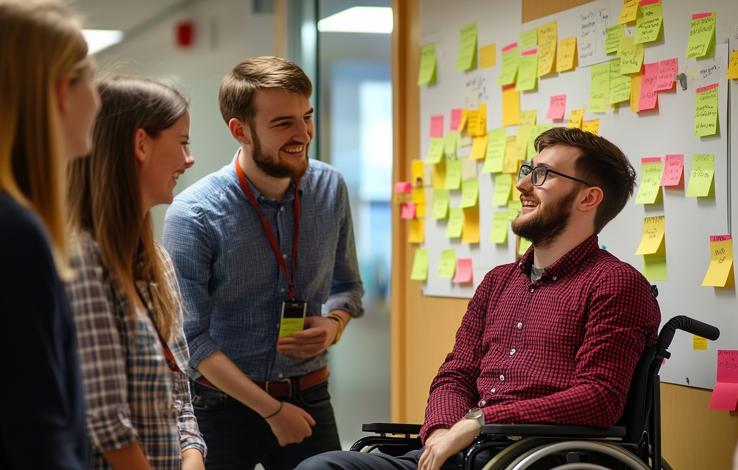

By prioritizing continuous improvement and inclusivity, the Elk Valley will ensure their accessibility efforts remain relevant and responsive to the needs of all members of their community.

How To Give Us Feedback

Ensuring accessibility of Elkford, Sparwood and Fernie’s public feedback mechanisms. Please let us know if there is another means of feedback not seen here.

District of Elkford:  744 Fording Drive, Box 340, Elkford, BC V0B 1H0 | 250-865-4000
accessibility@elkford.ca
District of Sparwood:  136 Spruce Ave, Box 520, Sparwood, BC V0B 2G0 | 250-425-6271
accessibility@sparwood.ca
City of Fernie:  501 3rd Ave, Box 190, Fernie, BC V0B 1M0 | 250-423-6817
accessibility@fernie.ca

Community Feedback
The Elk Valley Accessibility Survey highlighted significant barriers to accessibility in the community.
Not many people completed the survey, so the results should be taken cautiously as it is hard to make accurate conclusions across three municipalities without more responses.

Physical access to public spaces is either difficult or moderately difficult for 91.3% of the 92 people surveyed, an alarming percentage. Key challenges include limited ramps, elevators, and accessible restrooms, as well as inadequate programming for neurodiverse individuals.
Transportation & mobility were also major concerns, with 65.2% of respondents or someone they know experiencing difficulty getting where they need to go. Barriers such as limited sidewalks, poor snow clearing, insufficient accessible parking, and a lack of public transit were frequently cited.
Communication challenges were noted by 28.3% of respondents, who called for clearer, more accessible updates through multiple channels, including websites, social media, and print materials.
Employment barriers, including physical inaccessibility, toxic workplace culture, and insufficient accommodations, were also identified, alongside challenges in participating in community events due to inaccessible facilities and communication formats.
Emergency preparedness concerns included unclear evacuation plans and a lack of accessible procedures for individuals with diverse needs. To effectively address these barriers, it is essential to maintain ongoing engagement with the community, leveraging their insights and expertise.

29

Accessibility Committee Feedback

The Elk Valley Regional Accessibility Committee identified several accessibility barriers identified below:
Communication about community programs and emergency services: Inadequate or delayed communication methods and materials prevents members of the community from accessing important information about municipal operations, local programs, services and emergency measures.
Maintenance - long-term and seasonal: Lack of consistent and proper maintenance creates accessibility issues, such as snow accumulation or uneven surfaces, making it difficult or impossible to move around safely.
Physical access to businesses and buildings:
Automatic door buttons: The lack of or improper functioning of automatic door buttons can hinder individuals with mobility challenges, strollers and ageing individuals from independently accessing buildings.
Lifts and ramps: no municipal building should have restricted access due to stairs, steps or other existing thresholds. All measures need to be taken to ensure everyone is able to access City Hall, municipal offices, the Court House, and arenas.
Transportation: Insufficient infrastructure for public and active transportation, such as bus access, sidewalks, and pathways, impedes the mobility of all community members.

Ramps and curb cuts: Inadequate, poorly designed and maintained thresholds can pose significant barriers for individuals with mobility impairments, making it challenging for them to access buildings and navigate sidewalks, in turn, lessening their opportunities for gainful employment and severely reducing participation with friends, family and community members.
Accessible parking: Insufficient accessible parking spaces and improperly designed and maintained parking areas, including accessible parking spaces shared with families, are all barriers to access for individuals with mobility challenges and other disabilities who rely on designated parking spots.
Recreation facilities: Limited accessibility in both indoor and outdoor recreational areas and centers can restrict individuals from fully participating in and enjoying being active while negatively impacting their health and overall well-being.
Addressing these barriers is crucial to promoting inclusivity and equal access for all of our community members and guests.

Priorities

The three priorities outlined directly align with the eight key standards of the ABCA, addressing barriers and promoting inclusion across municipal services:

PRIORITY 1 - Education & Training
Implement a staff training program to build knowledge and understanding of accessibility to drive meaningful change.
This priority supports the Employment standard by fostering inclusive hiring practices and workplace cultures through staff education on accessibility, ableism, and disability awareness. Training municipal employees also aligns with the Delivery of Services standard, ensuring staff are equipped to meet the diverse needs of residents and visitors effectively. Change begins with mindset and perspective.

PRIORITY 2 - The Built Environment
Address the physical barriers in municipal spaces.
Set a strong example through action and leadership by turning attention to and budgeting for these barriers.
This priority directly supports the Built Environment standard, ensuring municipal infrastructure complies with accessibility requirements. It also demonstrates leadership in applying procurement policies that align with accessibility standards, connecting to the Procurement of Goods, Services, and Facilities standard.

PRIORITY 3 - Communication & Information
Improve communication by ensuring information is clear, accessible, and regularly shared across all platforms currently available to the municipality to meet the diverse needs of the community.
Clear and consistent communication fosters better understanding and builds a well-informed team.
This priority addresses the Information and Communication Technologies standard by ensuring that municipal websites, public information, and emergency plans are accessible to all residents. It also promotes inclusive communication methods, such as plain language and assistive technologies, to meet the diverse needs of individuals.


Together, these priorities reflect the priorities of the local population and municipal leaders. Showcasing the Elk Valley’s commitment to fulfilling ABCA standards and creating equitable, safe, and inclusive communities for all.

Action Plan

EMPLOYMENT & TRAINING
Goal: Inclusive employment practices and staff awareness training.

ACTIONS | METRICS OF SUCCESS | TIMELINE
Integrate images of PWD across municipal publications, digital and media platforms to mimic the diversity of people living in B.C.  Upon review and revision hiring practices will include descriptive, plain language and flexible work options.  Ongoing staff training on inclusive employment practices and execution.  Ongoing staff training on disability, ableism and intersectionality.  Ensure workplace assessments are completed for all employees, most especially those with disabilities.  Review this process with existing staff who have participated in the education programs. | % of digital and published materials that include representation of PWD. The minimum percentage goal meets or exceeds the national percentage of PWD (27%). | Report annually
 | % of hiring practices that have been reviewed and revised to include descriptive, plain language and flexible work options. | Report annually
 | Explore the specialised training and development options and create a list. This list is presented to the Accessibility Committee for their review and additional input. | 2026
 | Education and awareness training considered and included in future budget planning. | 2026 – Ongoing
 | # and % of staff who have participated in disability and inclusion training. | Report annually
 | # and % of staff that feel the workplace supports and encourages inclusion and diversity. | Every 3 years with the review and revision of this Plan
 | # and % of staff that feel they have increased knowledge and understanding of accessibility as a result of training. | Every 3 years with the review and revision of this Plan

THE BUILT ENVIRONMENT
Goal: Municipal owned infrastructure is barrier free and welcoming to all community members.

ACTIONS | METRICS OF SUCCESS | TIMELINE
Ensure barrier free access to all Municipal owned buildings and recreation facilities.  Priorities include:  - ramps  - auto door openers  - accessible washrooms  - elevators- accessible parking  - sidewalks, curb cuts  Inclusion of accessibility in all phases of ALL future RFPs, budget proposals and approvals.  Audits of municipal buildings and recreation centers must be conducted by professionals with expertise in disability and infrastructure analysis. | Develop a review system to audit municipal buildings and recreational facilities. | 2026 - 2027
 | % of municipal buildings audited for accessibility. | Report Annually
 | Priorities for maintenance and accessibility upgrades are created based on input from the community, the committee, and building audits. | 2025 - Ongoing
 | Explore accessibility improvements for inclusion in the budget process. | 2025 - Ongoing
 | Increase # and % of municipal buildings meeting the most current BC Building Code standards. | Report annually
 | # and % of municipal buildings accessible with automatic door opener mechanisms | Report annually
 | % of municipal buildings that are not accessible due to a step or stairs | Report annually
Increase the number of code compliant toilet and washroom/change facilities.  Consider Adult Change Facilities in future facilities upgrades and development. | # and location of wheelchair accessible toilets identified. This includes those renovated to comply with codes. | Report annually
 | # and location of Adult Change Facilities identified. The goal is 1 per community. | Report annually

THE BUILT ENVIRONMENT – continued

ACTIONS | METRICS OF SUCCESS | TIMELINE
Explore and implement strategies to increase numbers and safety of on-street and off-street accessible parking. Including:  - Short-term drop off zones (HandyDart)  - Van accessible parking spaces  Review current accessible parking standards and REVISE with best practice, including van accessible parking regulations. This can be done as a regional initiative. | # and % and location of van accessible parking spaces. | Report annually
 | # and location of accessible parking spaces within 200m of key infrastructure. | Report annually
 | No accessible parking spaces are shared with others. All are designed and indicated that they are specifically for persons with disabilities. | Report upon completion
 | Education provided to all existing and new bylaw staff members, encouraged to enforce proper parking in these spaces. | Ongoing
Review and revise planning regulations for wheelchair, scooter, and stroller accessible sidewalk and curb cut designs.  Include accessibility in all sidewalk infrastructure projects. Require contractors to submit an accessibility plan for all phases of construction, including wayfinding during construction. | Accessibility audit of main pedestrian routes, sidewalks, pathways and street crossings completed. | 2028
 | # and % of safe, accessible curb cuts. | Report annually
 | % of sidewalks remediated for threshold free compliance. | Report annually
Events and public meetings are held in accessible locations. | # of accessible community events and programs offered. | Report annually

COMMUNICATION & INFORMATION
Goal: Ensure all municipal communications and emergency preparedness plans are accessible and inclusive for all residents.

ACTIONS | METRICS OF SUCCESS | TIMELINE
Municipal websites meet (or exceed) website accessibility standards.  Offer alternative preferred communication methods to staff and the public - including but not limited to plain language, large print, ASL.  Create an online map of municipal facilities and services.  Include an accessibility option in the service request categories.  Provide frequent information updates in plain language to the public across all communication platforms.  Communicate the Annual Report with staff, the Committee and community members. | Websites are WCAG 2.1 compliant. | With website revisions and renewals.
 | An ASL interpreter that agrees to participate with the municipalities when the need arises is on the team. Also consider this person for participation at public events. | Begin the search as soon as possible.
 | Number of updates made to the accessibility map. | Report annually
 | Collect feedback through a survey and public engagement on the accessibility and responsiveness of municipal communications. | "3-5 years, with the Accessibility Report analysis and revision."
 | Post the annual report publicly with notifications across all communication platforms. | Annually

EMERGENCY PREPAREDNESS
Goal: Develop inclusive emergency preparedness plans that account for the diverse needs and safety of all residents and visitors.
ACTIONS | METRICS OF SUCCESS | TIMELINE
Consider provisions for transportation and evacuation of people with mobility challenges and severe disabilities living outside of facilities.  Provide clear, easily accessible communication in plain language, about emergency plans in multiple formats. | Review and revise emergency preparedness plans using an accessibility lens. | 2027 – 2028  Ongoing with planned revisions
 | Collect feedback through a survey and public engagement on the accessibility and practicality of the revised emergency plans. | 3 - 5 years  With Plan revision

POLICIES & PLANNING
Goal: Integrate accessibility into all municipal policies, future developments and bylaw enforcement.
ACTIONS | METRICS OF SUCCESS | TIMELINE
Review and revise municipal bylaws to include accessibility as a priority in all new developments and other municipal contracts.  Require accessibility reviews for revitalization projects and all new municipal projects. | # of policies, new and updated, that include accessibility requirements. | Report annually
 | % of new developments meeting accessibility standards. | Report annually
 | Report the changes made to planning controls to increase the compliance and amount of adaptable and accessible housing units. | Report annually

TRANSPORTATION & MOBILITY
Goal: Enhance transportation and mobility options to ensure all residents can navigate the community with safety, independence and dignity.

ACTIONS | METRICS OF SUCCESS | TIMELINE
Review and revise all procedures and policies that impact snow and ice control and prioritize accessibility.  Improve snow and ice removal for accessible parking spaces, sidewalks and curb cuts.  Snow and ice will never be knowingly shovelled into accessible parking spaces, curb cuts or onto sidewalks.  Advocate and support increasing the number of accessible bus stops.  Support increasing available accessible public transportation options - taxis, buses, shuttles, etc. through advocating to the appropriate channel ie. BC Transit.  Audible crossing cues budgeted for and implemented with ALL renewal and new crossing installations. | # of policies that impact snow and ice control and % of these that have undergone an accessibility review and revision. | Report annually
 | Identify the number of businesses in violation of snow removal bylaws. | Report annually
 | % of snow-cleared sidewalks and parking spaces within 24 hours of a snowfall. (Utilize the Accessibility Committee to inform this number) | Report annually
 | "# of complaints (including the small ones, in-person, phone calls, emails) related to accessibility of snow and ice removal received." | Report annually after the winter season
 | # of advocacy letters written regarding improving public transportation access. | Report annually
 | # and % of bus stops on municipal property that are accessible. | Report annually
 | Collect feedback from transit users on the impacts of this work. | Every 2-3 years
 | "Report on the progress of obtaining wheelchair accessible public transportation - taxi, bus, shuttle." | Report annually
 | Advocate together for better interconnected public transportation means in the Elk Valley - ie. writing letters to the province identifying the problems and needs of the community members. | 2025 - Ongoing
 | # and % of intersections with auditory crossing signals | Report annually
 | Request that MOTI intersections include auditory indicators at all their public crossings. | 2026 - Ongoing

Monitoring Progress

To ensure accountability and measurable progress, Elkford, Sparwood, and Fernie will work together to develop a robust monitoring and evaluation framework for their accessibility initiatives. Noting that the use of the same criteria will provide for cohesive analysis.

BIENNIAL MONITORING REPORTS
A comprehensive monitoring report will be prepared every two years, summarizing the Communities’ collective efforts to enhance accessibility. These reports will be presented during the first Accessibility Committee meeting of the fiscal year, ensuring transparency and providing an opportunity for feedback and discussion among members.

ACCESSIBILITY PLAN REVIEW AND REVISION
The Accessibility Plan will be thoroughly reviewed and evaluated every three years, starting from its adoption in 2025. This evaluation ensures that the plan remains effective, relevant, and adaptable to the evolving needs of the communities. Recognizing the limited reach of the initial survey that guided the plan’s priorities, Elkford, Sparwood, and Fernie are committed to developing a more inclusive and comprehensive engagement process before each revision. This process will include broader community consultations to ensure the plan reflects a wide range of voices and lived experiences.

ONGOING PUBLIC ENGAGEMENT
To promote transparency and encourage community participation, the Accessibility Plan will be published on the official websites of Elkford, Sparwood, and Fernie. By making this information publicly accessible, residents will have the opportunity to stay informed, provide feedback, and engage directly with the Communities’ ongoing accessibility initiatives.


CONTINUOUS IMPROVEMENT
The monitoring and evaluation outcomes are designed to identify areas for improvement, ensure accountability, and make necessary adjustments to enhance accessibility across all aspects of community life. By fostering collaboration and maintaining regular oversight, Elkford, Sparwood, and Fernie will continue to build inclusive environments where everyone can fully participate and flourish.

How To Give Us Feedback

Please use one of the following phone numbers, emails, mailing or physical addresses to deliver your constructive feedback to any of our participating municipalities.



District of Elkford
accessibility@ elkford.ca
744 Fording Drive, Box 340, Elkford, BC V0B 1H0
1-250-865-4000
District of Sparwood
accessibility@ sparwood.ca
136 Spruce Ave, Box 520, Sparwood, BC V0B 2G0
1-250-425-6271
City of Fernie
accessibility@fernie.ca
501 3rd Ave, Box 190, Fernie, BC V0B 1M0
1-250-423-6817

Provincial Feedback Mechanism

ACCESSIBILITY DIRECTORATE
You are encouraged to submit feedback online and/or write letters to
The Accessibility Directorate of BC.
The Accessibility Directorate is a government body within the Ministry of Social Development and Poverty Reduction in British Columbia. Its primary focus is to lead the province’s efforts to improve accessibility and promote inclusion for people with disabilities. The Directorate is responsible for implementing and supporting the ABCA, aiming to remove barriers and create a more inclusive society.
Both citizen and municipal letters describing the accessibility concerns and need for financial support will help in resolving some of the ongoing hurdles being faced in achieving the goals set out in this Plan.


Without the receipt of this feedback the Directorate may not be aware of the problems and financial struggles needing support in the community.

accessibility @gov.bc.ca
Accessibility Directorate
Ministry of Social Development and Poverty Reduction
PO Box 9929 Stn Prov Gov
Victoria, BC V8W 9R2

Our Commitment

Accessibility touches every aspect of our lives, often in ways we may not immediately recognize. By fostering awareness and understanding of the challenges faced by individuals with disabilities, Elkford, Sparwood, and Fernie are committed to creating barrier-free spaces that benefit all residents and visitors. This journey begins with a collective mindset shift toward inclusion, collaboration, creativity, and shared responsibility.
At this pivotal moment, the Elk Valley is united at the starting line, working together to prioritize accessibility and inclusion. By pooling resources and expertise, these communities—each with limited staff and resources—can navigate the path to equality and barrier-free access more effectively. This is not a process with an endpoint but rather an ongoing commitment to reviewing, learning, and adapting as we strive to build accessible and resilient communities where everyone has the opportunity to flourish.
To ensure accessibility remains a priority, regular reviews and updates to the Accessibility Plan, combined with frequent engagement with the Accessibility Committee, management, staff, and community members, will drive progress. By fostering curiosity, building capacity, and maintaining accountability, these efforts will pave the way for stronger, more inclusive communities for generations to come.


Appendix

Appendix 1 - Terms of Reference

ELK VALLEY
Regional Accessibility Committee Terms of Reference
- Committee Mandate
  - To assist the District of Elkford, District of Sparwood, and the Corporation of the City of Fernie (hereafter the “Communities”) in the development of an accessibility plan.
  - To assist the Communities in identifying and removing or preventing physical and social barriers to interacting with the organizations, or which impede the full participation of all citizens in every aspect of community life.
  - To provide a forum for discussion of issues affecting people with all types of accessibility challenges.
  - To raise the profile of accessibility matters in Elkford, Fernie, and Sparwood.
- Scope of Work
The Committee may conduct the following work:
  - Review, research, and consider information related to accessibility best practices.
  - Provide advice to improve accessibility on any matter or project referred by District councils or staff.
  - Assist with the analysis of current conditions of accessibility in Elkford and Sparwood.
  - Liaise with and hold discussions with government and non- government organizations as related to the Committee’s mandate.
  - Participate in the development, and any future modification, of the accessibility plans for each of the Communities.

  - With support from the Communities, solicit public feedback and engagement on matters related to the Committee’s mandate.
  - Develop a process for receiving comments from the public on any accessibility plan and barriers to individuals interacting with the Committee or Communities.
  - Report to the Districts and City on any aspect of this scope of work.
- Membership
  - Members shall be appointed by the Municipal CAO as described in this section.
  - The Committee shall consist of up to six voting members as follows:
    - One Member residing in the District of Elkford;
    - One Member residing in the City of Fernie;
    - One Member residing in the District of Sparwood;
    - To the extent possible, at least half of the Committee will include members from the community at large who are:
persons with disabilities, or
individuals who support, or are from organizations that support, persons with disabilities;
    - To the extent possible, at least one member of the Committee will be of Indigenous background.
  - The Committee will reflect the diversity of persons with
disabilities and the general population in British Columbia.
  - The Committee will appoint one representative from each of the Districts and the City, who shall alternate chairing meetings. The community responsible for hosting the meeting shall provide support to agenda preparation and logistics.
  - The CAOs may, at any time, remove any member of the Committee appointed by the CAOs.

  - Any member of the Committee may resign at any time upon sending written notice to the CAOs or staff liaisons for the Committee.
  - Committee members who are absent for three consecutive meetings shall forfeit their appointment unless such absence is authorized by agreement of the Municipal CAOs.
  - Committee members shall serve without remuneration.
- Tenure
The tenure of Committee members shall be for two years and may be extended by agreement of the CAOs.
- Meetings
  - The Committee shall meet as required to adequately address the Scope of Work in a timely manner.
  - The Committee must establish and post a meeting schedule.
  - All meetings must be open to the public.
  - Robert’s Rules of Order govern the meeting format.
- Quorum
Quorum of the Committee is the majority of all its members.
- Voting
All members of the Committee, including the chairs, have a vote. If the votes of the members present at the time of the vote are equal for and against a motion, the motion is defeated. For the purposes of counting the vote, any member who abstains from voting (except for a stated conflict of interest) has their vote counted in the affirmative.
- Minutes
  - Meeting minutes must be taken.

  - The Committee shall be responsible for keeping minutes and shall provide a copy of approved minutes to the Director of Corporate Services of each District and the City within five days of approval.
  - The minutes will be available to the public for review.
- Reporting to Council
  - The Chair shall report to its respective Council on behalf of the Committee once every three months and shall provide other reports to Council, as needed from time to time.
  - Recommendations of the Committee must be adopted by the Committee prior to presentation to Council.
- Representative Authority
  - The Committee does not have the authority to communicate with other levels of government on behalf of the Communities, to pledge the credit of the Communities, or to authorize any expenditure to be charged against the Communities.
  - If a Member serves on the Committee as a representative of an external group or organization, the Chair is authorized to communicate recommendations of the Committee to the external group or organization.
- Staff Support
  - The Chief Administrative Officer of each District and the City shall appoint a staff liaison to the Committee, as a non-voting member.
- Financial Resources
The Committee does not have a specific budget. Any budgetary needs must first be approved by the municipal CAOs.

Appendix 2: Survey Questions Qualitative Review

Accessibility Awareness and Experience
Are you, your friends, and family, able to use the public spaces (parks, leisure centers, city hall or district offices) in your community?
Yes - 53.3%
No - 16.3%
Some - 30.4%
If no, which ones can’t you use? (15 responses)
When asked about their ability to use specific public spaces, the respondents listed the following places as the ones that they cannot use:
- City Hall
- Court House
- Leisure Centre
- Library
- City yard
- Engineering in Ops Building
- Rotary Park
- District offices
A few locations were identified as possible to visit, although they also have barriers. Even if the spaces are accessible, getting to them presents a challenge for some respondents due to limited public transportation, few sidewalks, and lack of auditory street crossing signals. The upstairs hall in the recreation centre was described as inaccessible. The programming in the aquatic centre is limited (e.g., does not have offerings for children who are neurodiverse).

Prioritization of Accessibility Needs
What are the most important challenges that need to be fixed in order to allow you to use municipal buildings, parks and services? (Select all that apply) (89 responses)
The respondents prioritized the following areas for improving accessibility:
- Lack of Ramps or Elevators - 71.9%
- Inaccessible Restrooms - 40.4%
- Poor Lighting - 20.2% Staff - 13.5%
When responding to the question which services or buildings should be made more easy to get to or access first, most of the respondents emphasized the need to focus on City Hall & District Offices, Public Parks, and Leisure Centers.
Transportation and Mobility
How do you usually get around in your community? (Select all that apply) (92 responses)
Most of the respondents either drive/ride or walk around the community (78.3% and 67.4% respectively). Similarly, most of the respondents drive/ride and walk to get to municipal buildings. A third of respondents also bike.
Do you, or does someone you know, have any problems getting to where you/they need to go?
(92 responses)
Yes - 65.2%
No - 34.8%

Two thirds of the all the survey respondents said that they or someone they know have problems getting to where they need to go. The most common issues that respondents identified include the barriers that limit people’s mobility:
- Limited number of sidewalks
- Poor maintenance of sidewalks (sidewalks cracked and uneven)
- Snow clearing is inadequate
- Shortage of accessible parking spaces, including van accessible parking
- Lack of public transit to navigate the community
- Barriers to access the City Hall and other municipal buildings
Communication and Information Accessibility
Are the ways we currently communicate with you easy to use and available to everyone? (92 responses)
Yes - 71.7%
No - 28.3%
If no, how can we communicate with you better?
Most of the respondents indicated the importance of using multiple channels of communication. In addition to the importance of regularly updating the city’s official website and social media, some residents recommended the use of print flyers and emails. In case of time sensitive information, such as advisories, the information needs to be shared through a variety of means. The respondents also recommended sharing more information about the city projects (e.g., status, costs). Finally, the respondents expressed the need to increase responsiveness to the requests for service.

Employment and Community Engagement
Do you face any challenges related to getting a job with the District or City?
If yes, what are they? (36 responses)
The respondents shared that their disability was a factor in preventing them from getting hired. Barriers that exist for people with mobility and sensory disabilities limit the opportunities to find a job in the city. The respondents also mentioned a toxic work culture that disincentivizes people from working there. Finally, the barriers in the built environment make it challenging for someone who wants to consider working for the city.
Do you face challenges that make it difficult or impossible to do your job? If yes, what are they? (82 responses)
When asked about the challenges that make it difficult or impossible to do their job, the respondents discussed both their physical and other limitations related to their disabilities (e.g., pain, fatigue, difficulty walking) as well as the barriers in the environment, including inaccessible sidewalks (due to poor snow clearing), icy road conditions, lack of programming for people with different disabilities, and lack of allied health specialists (e.g., speech language pathologists, occupational therapists, etc.).
Are there any build environment or communication challenges stopping you from taking part in community events (examples: markets, festivals) or public meetings (examples: council meetings, open houses)? (82 responses)

In terms of the specific challenges preventing the community members from participating in community events and public meetings, such things as lack of public transit, inaccessible sidewalks, ramps, parking, washroom facilities were mentioned as factors that prevent people from attending the events. As well, a failure to share information in accessible formats is another barrier.
Emergency Preparedness
Are there any specific issues related to accessing emergency preparedness information and plan execution that should be addressed? If yes, what are they? (82 responses)
The respondents listed a few barriers related to emergency preparedness. Specifically, one of the most critical aspects of emergency preparedness that they expressed concerns about is communication (everything from what the current evacuation plan is to how it can be accessed to how the information about emergency is going to be shared). The respondents emphasized the importance to making this information available to businesses, especially a busy tourist season. They also mentioned the importance for the information and procedures to be clear, easily accessible, and simplified. Education sessions were suggested. One of the concerns shared by the respondents was about those who do not have access to the vehicle and the importance of considering people with different access needs in the emergency preparedness plan.
Suggestions and Additional Comments
Do you have any suggestions for better access in our communities that have not been covered in this survey? If yes, what are they? (84 responses)

In addition to reiterating some of the points that have been made about the overall level of inaccessibility in the city and the need for public transportation, better snow clearing, more accessible parking, the respondents brought forward the importance of including different stakeholders to adopt accessible practices. One respondent noted,

Adopting bylaws that require not just the city but all service providers in the city to adopt ADA best practices. All types of people live in our valley and all of us should be able to move about and participate with ease.

Another participant talked about the importance of thinking about accessibility more broadly and include aspects related to the creation of sensory friendly spaces and services. In addition, it was brought up that no new developments should have accessibility barriers. As this respondent noted,

Particularly when proposing new facilities, view plans and policies with an accessibility lens. With the advancements in accessibility options now available, there is zero reason why any new building should not work for everyone.

Finally, it is important for the city to learn from the community and develop a truly accessible community with input from the community. As one respondent noted,

The City has a long way to go and this is the tip of the iceberg. There is a lot of
experience and knowledge within the community that City of Fernie is not tapping into!

Appendix 3: Research

Intersectional Accessibility Lens
https://accessible.canada.ca/can-asc-1-1/AnnexD

Accessibility Lens Definition
https://www.deafwireless.ca/index.php/terminology /accessibility-lens/

Disability Definitions
Language - Communication with words and images https://www.canada.ca/en/employment-social- development/programs/disability/arc/words-images.html

Accessible parking standards
https://www.richmond.ca/ shared/assets/ParkingLoading24226.pdf

Appendix 4: Educational Resources

Models of disability.
https://bcaccessibilityhub.ca/resources/best-practices-and-research/
Hosting inclusive meetings and events. https://www2.gov.bc.ca/gov/content/home/accessible-
government/toolkit/meetings-and-events
Accessibility training.
https://bclaconnect.ca/resources/continuing-education-
resources/untapped-accessibility-training/
Accessibility and Inclusion in the Workplace Course (for public sector organisations) - Oct 18 - Dec 13, 2024.
https://www.civicinfo.bc.ca/events?eventid=9277
Inclusive Employer Self Assessment
https://disabilityinclusion.ca/your-disability-inclusive-employer-self- assessment-results/?entry_key=hkpp9#main
Municipal accessibility support program - free online training and webinars.
https://www.accessibility-program.ca/education-and-training/free- online-training-and-webinars
Universal washroom design. https://www.changing-places.org/
Way With Words. https://www.canada.ca/content/dam/esdc-
edsc/migration/documents/eng/disability/arc/way_with_words.pdf 56

Blindness etiquette.
https://www.cnib.ca/en/be-natural-4-common-courtesies-offer- people-who-are-blind?region=bc
Web Accessibility Initiative - stories of users. https://www.w3.org/WAI/people-use-web/user-stories/#shopper
Communication with and about persons with disabilities. https://www.cdc.gov/ncbddd/disabilityandhealth/materials/fact
sheets/fs-communicating-with-people.html
Empowering people with disabilities in research and design. https://www.researchgate.net/publication/329246799_
Beyond_Participation_Empowering_People_with_Disabilities_in_Researc h_and_Design
Inclusive language in media.
https://www.humber.ca/makingaccessiblemedia/modules/
06/transript/Final_Glossary.pdf
Inclusion of intellectual disabilities. https://www.researchgate.net/publication/5579735_Photovoice_
as_Participatory_Action_Research_Tool_for_Engaging_People_With_Intell ectual_Disabilities_in_Research_and_Program_Development
Website accessibility standards. https://www.w3.org/WAI/standards-guidelines/wcag/
Accessible community bylaws. https://www.lakecountry.bc.ca/media/file/accessible-community-
bylaws-guide

Accessibility standards and guide.
https://novascotia.ca/accessibility/resources/
Guide for putting on an accessible event. https://accessibility.ku.edu/best-practice-guidelines-planning-
accessible-event
Emergency preparedness and accessibility. https://www.tandfonline.com/doi/abs/10.1080/0963
8288.2018.1550686
Accessible parking standards.
https://www.richmond.ca/ shared/assets/ParkingLoading24226.pdf
Accessibility advisory committee recommendations. https://inclusivemap.ca/recommendations-for-accessibility-advisory-
committee-engagement/

Appendix 5: Local Disability Serving Organizations & Groups

Fernie Ride Share
https://www.facebook.com/groups/735924303215236/
Elkford’s Diverse Abilities Support Group https://www.facebook.com/groups/739101866530829/?locale=fo_FO
Canucks Autism Network (CAN)
CAN will help make your organisation more accessible, welcoming and inclusive.
https://canucksautism.ca/
Family Action Network
Regional community support services and references to other available services.
https://familyactionnetwork.ca/regional-services/community- support-services/
Neil Squire Society
Computer assistive technologies, research and development, and employment programs for persons with physical disabilities.
https://www.neilsquire.ca/
Disability Alliance of BC
Supports people with all disabilities to live with dignity, independence and as equal and full participants in the community.
https://disabilityalliancebc.org/

Community Living British Columbia
Promotes the participation of people with developmental disabilities in all aspects of community life.
https://www.communitylivingbc.ca/
Employment Programs & Support Career Development Services Career development services.
https://cdskootenays.com/cds-programs/employment-programs- and-support/ and https://cdskootenays.com/cds-programs/outreach- and-community-inclusion-programs/

Appendix 6: Grant Opportunities

BC Local Government Grants Growing Communities Fund Infrastructure Grants
Regional district basic grants - administrative cost assistance grant Small Community Grants https://www2.gov.bc.ca/gov/content/governments/local- governments/grants-transfers
Union of BC Municipalities
Canada Community-Building Fund Local Government Program Services
https://www.ubcm.ca/funding-programs
Enabling Accessibility Fund Youth innovation component Small project component
Mid-size projects components https://www.canada.ca/en/employment-social- development/programs/enabling-accessibility-fund.html

SPARC BC
Local Community Accessibility Grant https://www.sparc.bc.ca/wp-content/uploads/2023/06/Local- Community-Accessibility-Grant-Application-Form-V2.pdf

Appendix 7: Resources

https://www2.gov.bc.ca/gov/content/governments/about-the-bc- government/accessibility/legislation
https://www2.gov.bc.ca/gov/content/governments/about-the-bc- government/accessibility/legislation/accessiblebc
https://www2.gov.bc.ca/assets/gov/farming-natural-resources-and-industry/construction- industry/building-codes-and- standards/guides/building_accessibility_handbook_updatedjune2021.pdf https://bcaccessibilityhub.ca/
https://www150.statcan.gc.ca/n1/en/catalogue/89-654-X https://www.fernie.ca/assets/City~Hall/Departments/Corporate~Administration/docs/RDEK%20EVSC
%20Emergency%20Management%20Procedures.pdf https://novascotia.ca/accessibility/
https://www.whistler.ca/services/accessibility/accessible-policy-and-plans-action/development- rmow-accessibility-policy/
https://www.w3.org/WAI/tips/designing/ https://www.ada.gov/
https://www.nanaimo.ca/your-government/accessibility-inclusion
https://prrd.bc.ca/wp-content/uploads/page/accessibility/Northeastern-BC-Collaborative- Accessibility-Plan-FINAL.pdf
https://www.penticton.ca/sites/default/files/docs/city- services/social%20development/City%20of%20Penticton%20Accessibility%20Plan%202023- 2026.pdf
https://www.cityofsydney.nsw.gov.au/strategies-action-plans/inclusion-disability-action-plan
https://laws-lois.justice.gc.ca/eng/acts/h-6/
https://www2.gov.bc.ca/gov/content/industry/construction-industry/building-codes-standards/bc- codes/2024-bc-codes https://dnv-docs.simplicitycms.ca/documents/accessibility-plan-2023.pdf
https://accessibilitycanada.ca/legislation/nova-scotia-accessibility-act/
https://inclusivemap.ca/recommendations-for-accessibility-advisory-committee-engagement/
https://www.regionofqueens.com/municipal-services/planning/accessibility

